**Grumpy Joe’s Coffee**

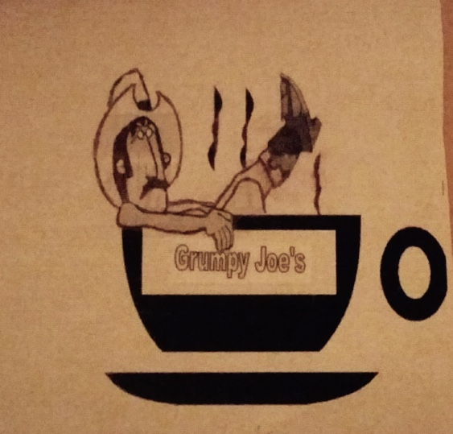**Group 4:**

*Adrian Rivera-Zayas, Kayla Gordon, Jonathan Oh, Mehreen Mohsin*

**Class: MKT 3300.011**

**Date: April 3rd, 2016**

**Table of Contents**

**1. Executive Summary:Adrian**

Grumpy Joe’s is an all-new coffee chain that focuses on quality and individuality. It’s trademark coffee is paired with hilarious names that will be sure to strike a conversation with anybody who walks in through the door. The target market for this quirky company are mostly college students and young employees in the workforce (20-35 years old).

The first shop to be opened will be as close as possible to The University of Texas at Dallas, because there is a huge need for a 24/7 coffee shop to be located near campus that simultaneously caters to college students and has great quality coffee. The way that Grumpy Joe’s will build brand awareness is to put flyers on campus around UTD, have radio advertisements on the student-run radio station at UTD, and also have a discount in effect for customers who show their comet card to the cashier (10%). The main goal of all these advertisements is to gain a somewhat “cult” following of loyal students who feel that Joe’s coffee shop feels like a home away from home, and that the company will continue to keep the comet spirit alive with great customer service and wonderful coffee.

Once Grumpy Joe’s has built enough brand awareness and profits have started to grow, the company will also sell beans in bags to customers who wish to take some coffee home to roast on their own. This business decision has been carefully thought out and decided to be acted upon due to market research that has shown “difficult economic times in the 2008-2010 period resulting(sic) in more coffee drinkers buying specialty coffee to brew at home rather than buy their morning coffee at a shop.” So, instead of trying to fight the trend and force customers to buy coffee in-store instead of brewing their own, and in turn shrinking the company’s potential customer base, Joe’s chooses to adapt and sell its beans instead. Remarkably, research shows that for the company’s most loyal customers, they won’t want to brew their coffee from home, because they enjoy conversing with Joe’s staff each morning and having a good start to their day with the interactions that separates our company from the rest.

The main point of differences that the company has, in comparison to your run-of-the-mill coffee shops, are friendly staff, great customer service, witty representatives on social media, unique product quality, and focus on being college-centric. Joe’s wants to create the most personal and striking experience a coffee shop can have on its community.

**2. Company Description: Adrian**

Grumpy Joe’s coffee will start sometime this year by co-founders Adrian Rivera-Zayas, Kayla Gordon, Jonathan Oh, and Mehreen Mohsin to develop and market a unique blend of coffee mixed with charming customer service to the community. The company will first be introduced to Richardson and then expand to other stores in the nearby area, the exact year depending upon revenue.

To the company’s knowledge, Grumpy Joe’s is the only premium-quality coffee shop that is near UTD that is catered specifically for the diverse student body located there. Projections show that the store will gain copious popularity within the ranks of the UTD student body and in correspondence, around the entire surrounding community. The company believes that the target market of Grumpy Joe’s will not just be the college body, but eventually expand to younger members of the workforce, due to the domino effect of friends introducing their friends to the first shop due to the funny product names and quality coffee.

Grumpy Joe’s believes its high-quality coffee and high emphasis on customer service to prove very successful upon opening and that the company will be able to expand to other parts of the Dallas-Fort Worth Metroplex area.

**3.Strategic Focus and Plan;Mehreen**

**Mission**

**Goals**

**Core Competency and Sustainable Competitive Advantage**

**4. Situation Analysis: Adrian**

The table shows the internal and external factors affecting the market opportunities and barriers to entry for the company. This SWOT analysis highlights the valuable aspects of Grumpy Joe’s as well as the weak points.

**SWOT Analysis**

The biggest strengths to Grumpy Joe’s are coffee with great flavor, a convenient location, around the clock availability, competitive prices, the fact that the coffee industry is rapidly expanding, and that there is no true competitive product to coffee which provides a truly unique benefit. The major weakness to our company is the huge market share competitors have, this is expanded upon more in the competitor analysis.

|  |  |  |
| --- | --- | --- |
| **Internal Factors** | **Strengths** | **Weaknesses** |
| Management | Part of the target market smart business decision that will resonate with market | Small size can restrict options |
| Offerings | High-quality, normal market price products | Many lower-quality, cheaper alternatives |
| Marketing | Huge market, unique marketing scheme by advertising at UTD | Many other competitors are popular at colleges nationwide, mainly Starbucks as a class symbol |
| Personnel | Staff knows how to interact with customers since they are young and peers of the market | High turnover rate, many young people change jobs seasonally |
| Finance | Low cost company because coffee is cheap to buy from distributors and has a premium price | Can be difficult to be break even at first since gaining dedicated customers will be difficult at first |
| Manufacturing | Coffee cups are cheap to make since they are mostly made out of cardboard, cups are the majority of things we will need to manufacture | Will be difficult finding a plant at first when the company begins |
| R&D | Experimentation with different drink flavors is a constant | Many of the flavors will be hit-or-miss and we will require a lot of feedback from consumers |
| **External Factors** | **Opportunities** | **Threats** |
| Consumer/Social | There is a huge untapped need for a coffee store near UTD that is catered to college students, market likely to be stable, coffee drinking has been established as a fun activity to share with friends | Starbucks has a big social media presence, premium price may limit access to market at first |
| Competitive | Distinctive product names and branding | Starbucks has a huge market share along with Dunkin Donuts, coffee not patentable |
| Technological | Breakthroughs would enable less beans roasted for same amount of coffee being brewed | In-house brewing machines becoming very popular |
| Economic | Consumer habitually buying daily will create a steady income for the business, we can also afford to sample to many consumers | Many people are brewing their own coffee instead of going out now |
| Legal/Regulatory | FDA standards eliminate disreputable competitors | Large competitors have big legal teams |

**Industry Analysis**

Coffee shops make up the FASTEST GROWING part of the restaurant business, checking in with a 7% annual growth rate! Americans consume 400 million cups of coffee per day, or equivalent to 146,000,000,000 (146 Billion) cups of coffee per year; making the United States the LEADING CONSUMER of coffee in the world. More than half of all Americans over the age of 18 -- 107 million people -- drink coffee daily. On average, U.S. coffee drinkers consume three and a half cups a day apiece. The retail value of the U.S. coffee market is estimated at $30-32 billion dollars, with specialty comprising approximately a 37% volume share but nearly 50% value share. The industry is very competitive, with Starbucks and Dunkin Donuts sharing the majority of the market.

**Competitor Analysis**

Grumpy Joe’s major competitors are Starbucks, Dunkin Donuts and Cafe Brazil. Starbucks has 33% of market share in U.S. while Dunkin Donuts has 16% of market share in the U.S. If a number one competitor needs to be specified, Cafe Brazil would be it due to having 24/7 availability and the closest proximity to the UTD campus. The strengths of the company’s competitors would be that the type of customers they attract are young business professionals, which is part of the market we are targeting and also that they have very strong brand recognition. The weaknesses would be that the companies have no personal touches in their interactions with customers, since they are huge they have lost their touch that they once had with their customers. The main point of difference that these companies focus on are the quality of their coffee, and the convenience factor of a drive-thru. The main point is that competitors have an established consumer base, and Grumpy Joe’s needs to create a local customer base at first, specifically targeting college students within the area and young professionals.

**Company Analysis**

Although the coffee shop industry is expanding, difficult economic times in the 2008-2010 period resulted in more coffee drinkers buying specialty coffee to brew at home rather than buy their morning coffee at a shop. This has prompted the rise of small specialty roasters to fill the retail demand for gourmet coffee beans. Fortunately Grumpy Joe’s perfectly fits within that group and can fill the need for gourmet coffee. It is difficult to run a full analysis of the company unfortunately, since it hasn’t been launched yet.

***Customer Characteristics***

Based on our survey and research of the Richardson area, Grumpy Joe’s main customers will be students looking for a place to study at all parts of the days from the ages of 18-24, and business people looking to drink a cup of coffee even at the early parts of the morning around the ages of 25-40 years old.

**5. Market-Product Focus: Jonathan**

**Marketing and Product Objectives**

Ultimately, Grumpy Joe’s wants to be a quality coffee shop. We will market ourselves as not only a quality coffee shop, but an experience you cannot find at any other coffee shop. With our highly rated products and quirky product titles, we believe that we can build a loyal customer base. With this loyal customer base, we intend on opening a second location as we believe we will be financially established to do so.

**Target Markets**

Our target market is clearly geared towards a more mature audience. More specifically, we wanted our focus on students who are studying late into the night and need that extra boost of energy to keep themselves going. Additionally, our products are not only catered to students but also professionals. Business people work early mornings and into the late night, even they need coffee to keep themselves going!

Our reasoning for targeting these specific groups is quite simple actually. First, with our quirky menu titles and advertising position, we find that an immature audience may not receive these jokes as well as a mature audience. Also, we have acknowledged the fact that our menu titles are most definitely not catered towards children so focusing on a younger audience would only come back to hurt us. Secondly, since we decided on a near campus location, it was the most logical decision to target students. Our rationale for this was, “Some students stay up late to study and do not enjoy studying at home due to distractions. Let’s give them a place to study.” Finally, we targeted older business people due to the fact that most business people desire a cup of coffee in the morning before heading off to work.

**Points of Difference**

Our point of difference is very clear. With Grumpy Joe’s, we aim to have people satisfied with what they bought and we want that shock value added when they buy our products. For instance, here is a list of some of our menu items.

* Big Black Coffee
* Four Twen-Tea
* Basic B*tch

We want our drinks to not only be funny, but also maintain a good enough quality to have people coming back for more. WIth Grumpy Joe’s, we will only serve coffee if it maintains a 5 star rating.

**Positioning**

For the business people who are on the go or the student looking to have a late night study session and looking for a quality experience but can also appreciate a business that is not afraid to sit outside the comfort zone, Grumpy Joe’s is for them.

**6. Marketing Program: Jonathan**

**Product Strategy**

At Grumpy Joe’s we believe we will primarily catch our customer’s eye through our product titles. We want people to think to themselves, “what the heck? A Four Twen-Tea? That’s hilarious!” This is where our product quality secures us. Once the customers have not only laughed at the funny product titles, they will also enjoy the product itself and will spread the word amongst their colleagues about how funny and good their experience was.

**Price Strategy**

When it comes to pricing, our approach was to look at surrounding coffee shop locations and determine what prices we thought was fair. For instance, we believe Starbucks is most definitely overpriced but most buy their products due to the image of having a Starbucks coffee. At Grumpy Joe’s we desire this amount of success and believe we can have lower than prices than Starbucks but still achieve our end goals with these fair prices.

For specific price examples: a small coffee will cost $2.25, a small tea will cost $3.75, and a small hot chocolate will cost $3.25. While these prices may seem high to some, through research we found that our prices are indeed lower than some of our competitors.

**Promotion Strategy**

When advertising our products, we have constructed the names in such a way that they will advertise themselves. Additionally, for many of our products, we created a slogan aiming to get a quick chuckle out of people and hopefully getting them to think, “wow I want to try that.” For example, with our “Erectile Disfunction” coffee, the slogan would be, “Have a hard time getting up? Well we have a drink that will suit you!” We have accepted that our mottos may offend some, but we believe as a company, it will help us stand out from the crowd.

**Recipes**

Grumpy Joe’s will have all of a coffee fan’s favorites. Ranging from a standard black coffee to salted caramel lattes and a multitude of specialty drinks, our customers will be satisfied with our vast menu variety. Additionally, our coffees will be made with only high quality coffee beans to ensure we have a drink that will keep customers coming back for more.

**Cents-Off Coupons**

With UTD students, Grumpy Joe’s intends on offering a discount of 10% for those who present their Comet Card upon purchase. We feel that this will be most beneficial in the long run as it will aid our sales in the beginning of our business. Once we feel that we have a wide enough audience, we may offer additional specials but for the time being, this is the most attractive option for our company.

**Place (Distribution Strategy)**

Grumpy Joe’s will be located two blocks away from the University of Texas at Dallas. We believe with this location, we are only setting ourselves up for success. The intersection at Campbell and Coit is a high traffic area that will surely generate customers for our shop.

**7. Financial Data and Projections: Kayla**

**First-Year Projections**

Grumpy Joe’s has projected over a 300% return on investment within the first 12 months with an initial investment of $53,000. The initial investment will help Grumpy Joe’s with the primary costs of opening the doors to the public which will include leasing the property, renovations that will meet food and beverage regulations, as well as one time purchases of coffee makers and a cash register.  As projected in figure 1, the monthly expenses of both variable and fixed costs over the next 12 months and the predetermined pricing of the products, Grumpy Joe’s will not only have monthly revenue but also a monthly profit that will help Grumpy Joe’s to provide a return on investment to the investors but also allow Grumpy Joe’s to become self-sufficient within the first 12 months.  Included in the month expense report is a dedicated amount to provide to the marketing plan. As seen in figure 2, marketing the Grumpy Joe’s brand to the public will consist of approximately 6% of our total expenses. Fixed monthly expenses, which consist of the monthly leasing price, will be the highest contribution to expenses.

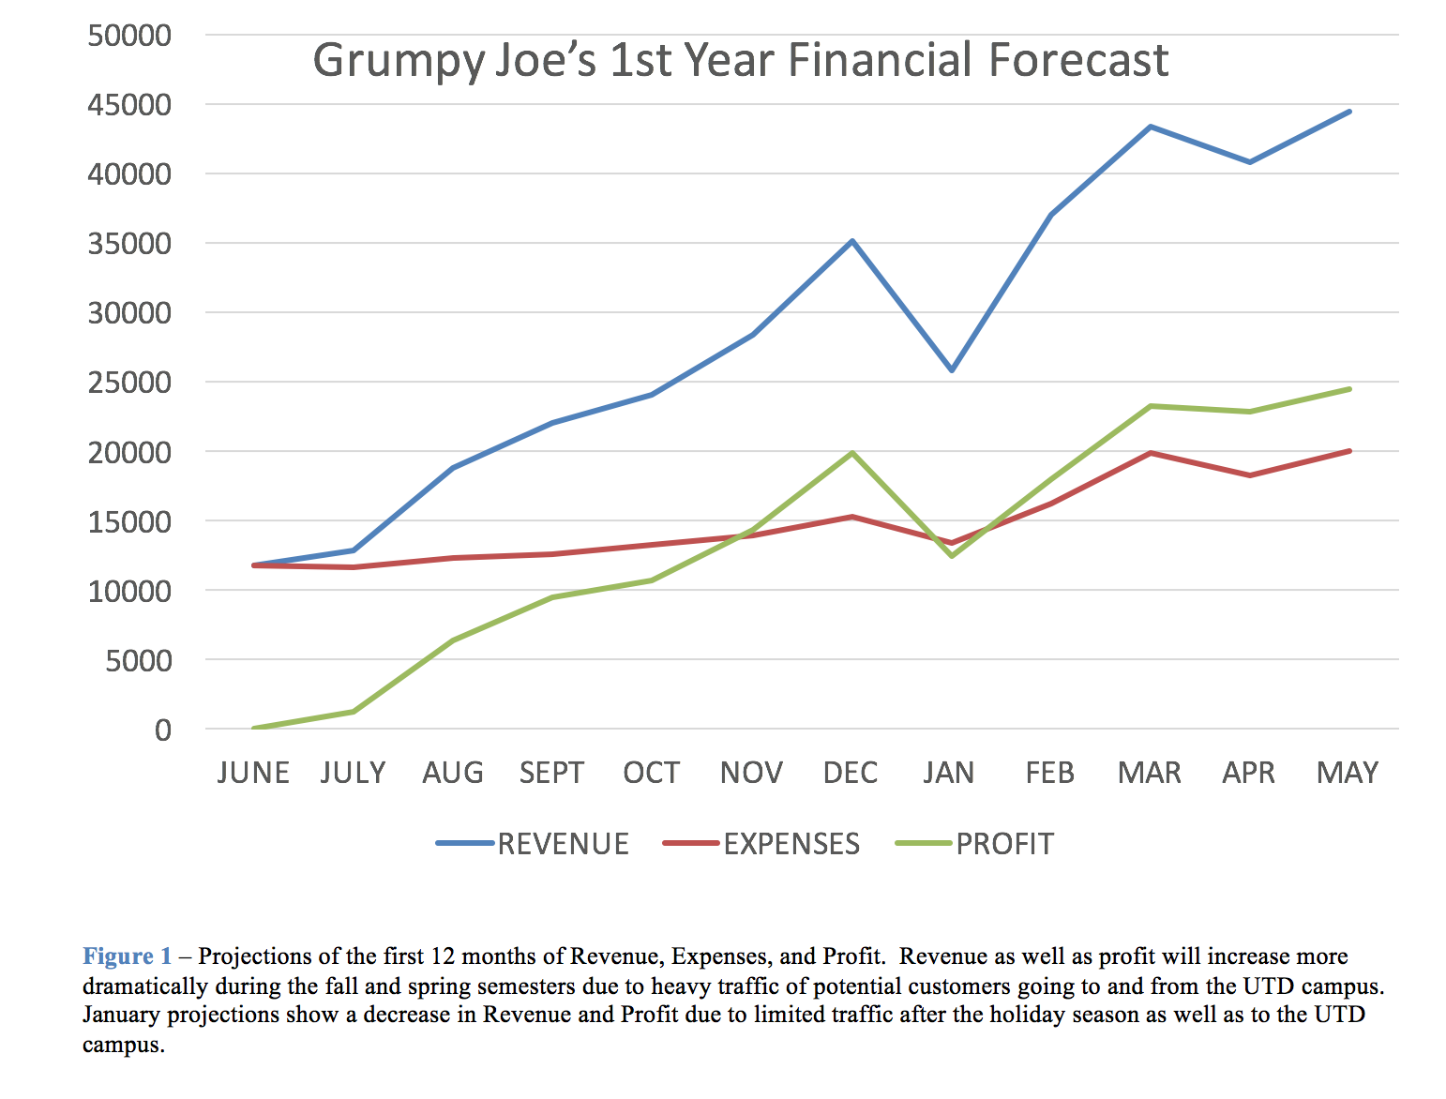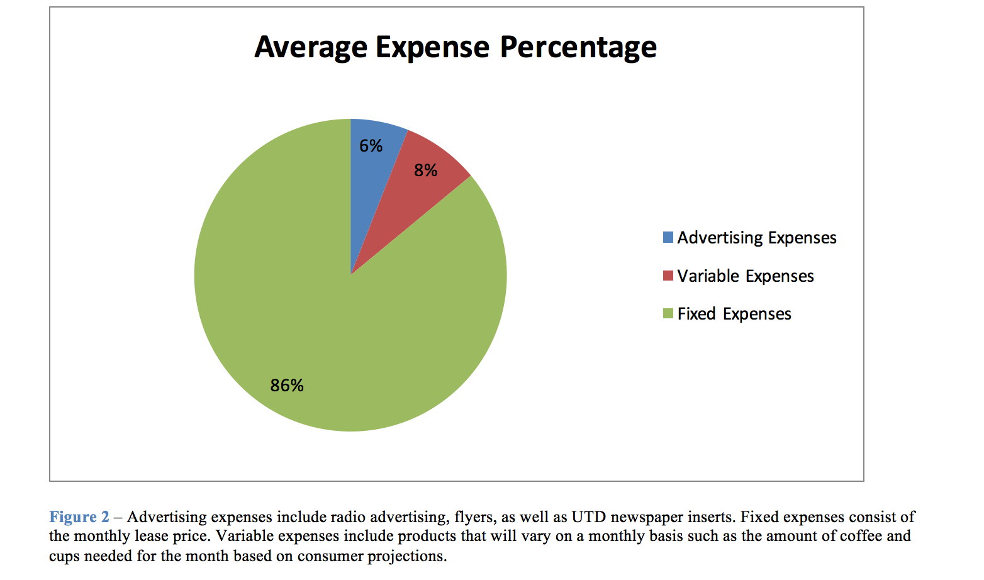

**8. Organization: Kayla**

Grumpy Joe’s is a small company that will consist of the 4 original founders as the main and only employees for the first 4 months of being open.  Grumpy Joes’ organizational layout is a horizontal organization that allows each employee an equal share of responsibility based on each position title. Each founder has a specific function to Grumpy Joe’s that will ensure the success of the company. Below is a representation of the organization and positions of each of the 4 founders of Grumpy Joe’s.

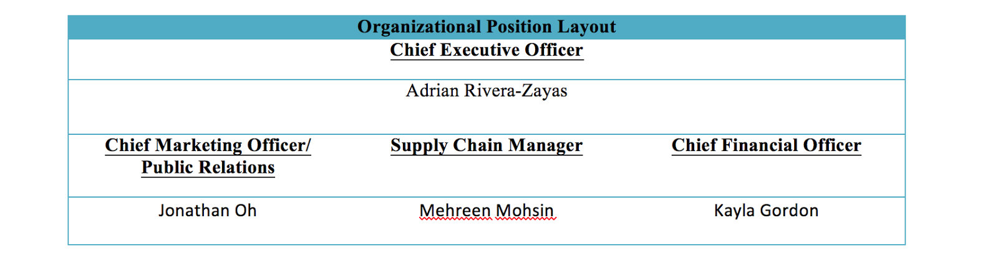

**9.Implementation Plan: Mehreen**

**10.Evaluation: Mehreen**

**Bibliography**

**"The History of Coffee." PBS. PBS, 22 May 2003. Web. 25 Apr. 2016.**

**•"Working Americans: Average Amount Spent on Coffee at Work, 2013 | Statistic." Statista. N.p., n.d. Web. 25 Apr. 2016.**

**•"Coffee Statistics Report 2014 Edition." Coffee Statistics Report 2014. N.p., n.d. Web. 25 Apr. 2016.**